**Sequence Diagram:**

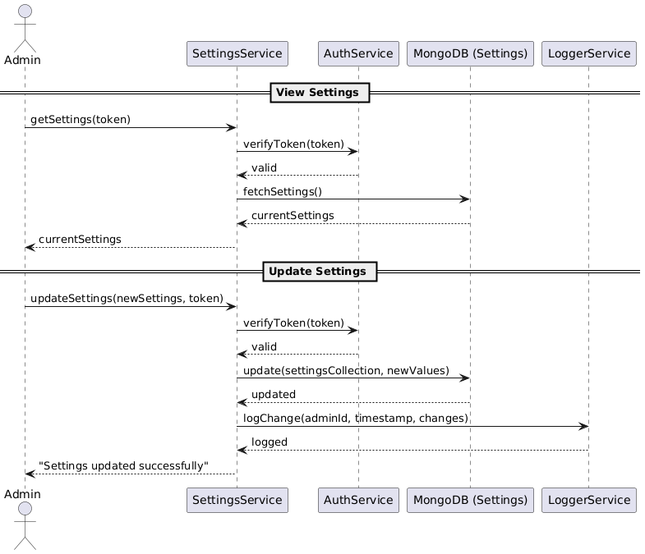

**Class Diagram:**

**State Diagram:**



**ERD:**

**Functional Requirements**

1. Admins should be able to view and update system settings.
2. Settings include app-wide preferences such as email notifications, user role permissions, maintenance mode, and content filters.
3. Settings changes must be logged with timestamp and admin ID.
4. System should fetch current settings at application start or when requested.
5. Only authenticated admins should be allowed to modify settings.
6. Settings should persist across application restarts.

**Non-Functional Requirements**

1. Settings changes must reflect within 1 minute across all modules.
2. Only admins with proper roles should access or change settings.
3. Log every change to settings with historical record.
4. Store encrypted sensitive keys like API tokens in settings.